LabSheet 5
Hibernate Program using Annotation(Maven)
Problem Statement : Student mark processing using Hibernate with Maven

Step 1: Create Maven Project (Eclipse)
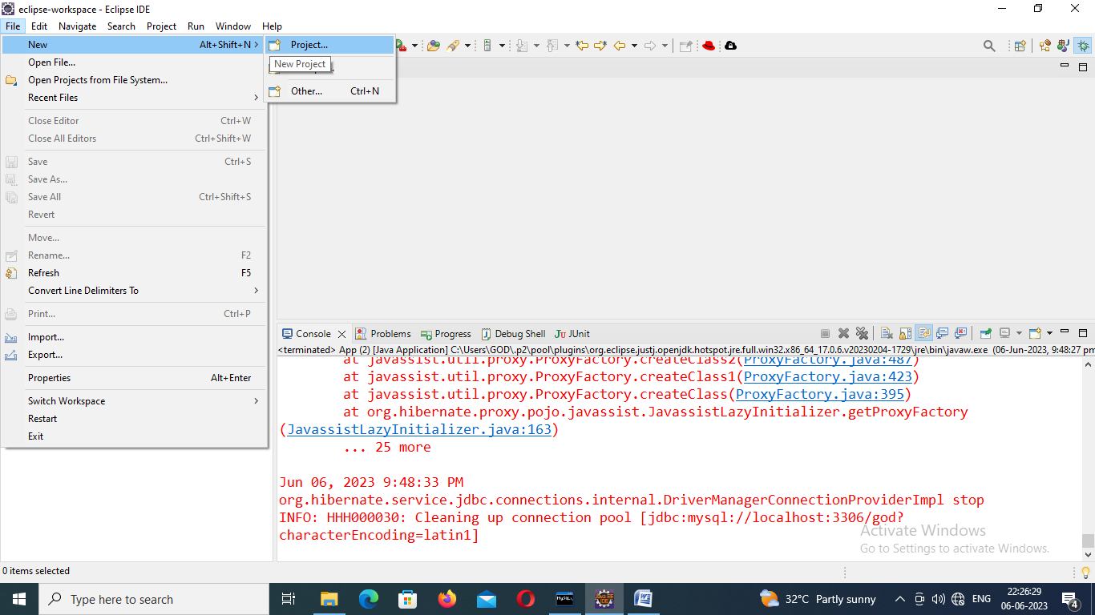

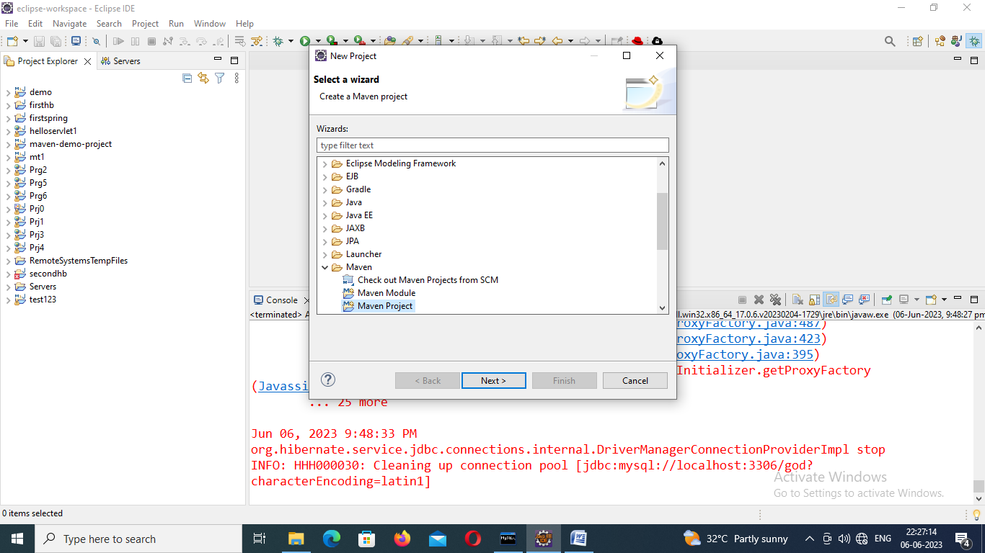
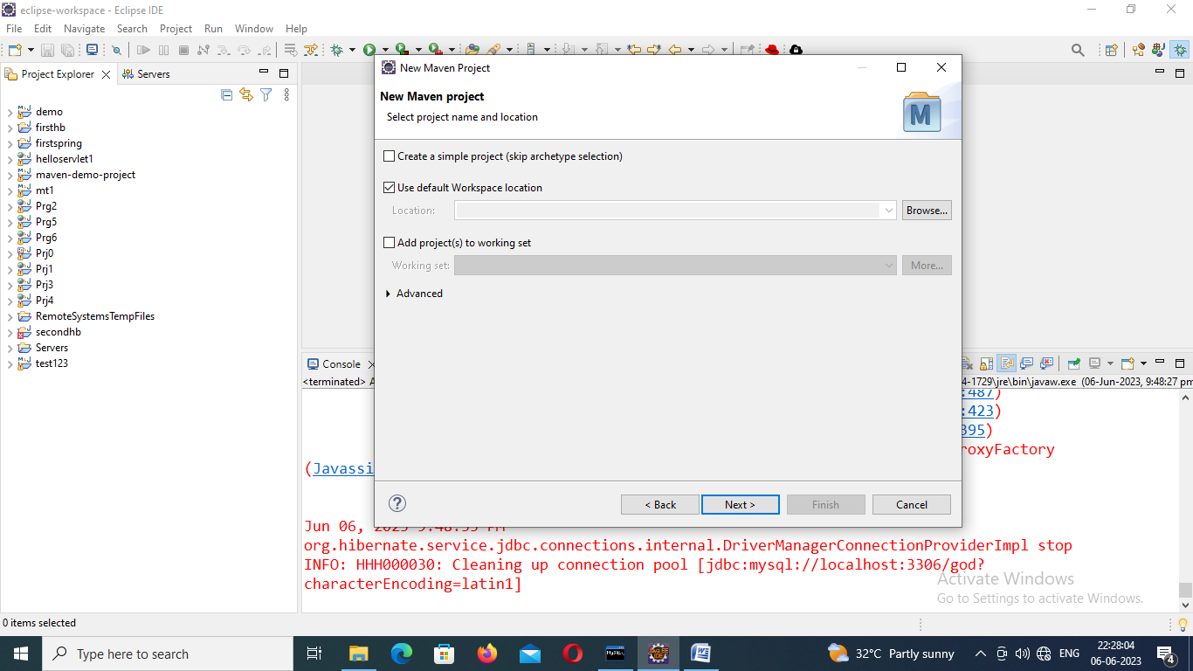

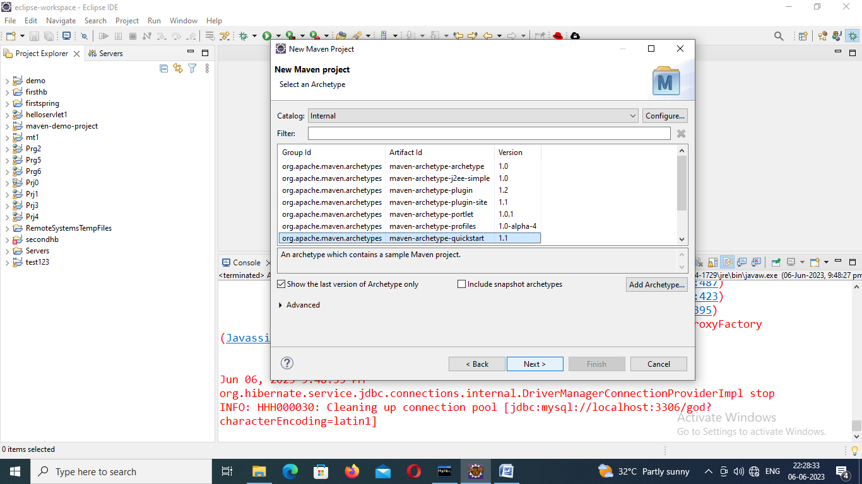

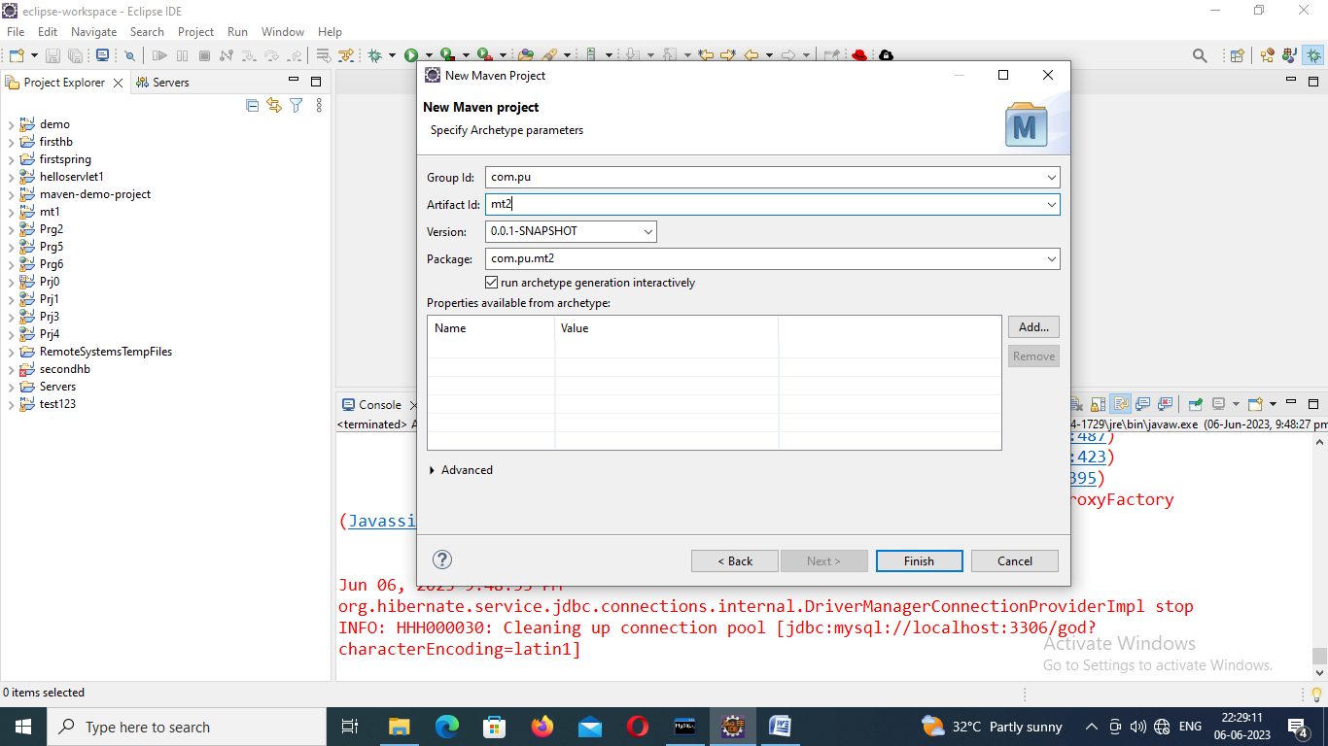

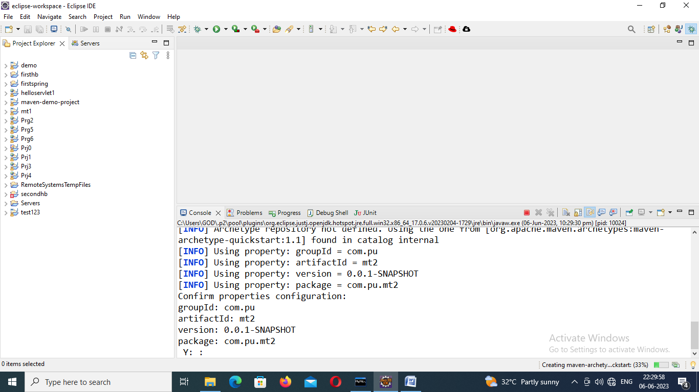

Step 2: Install JBoss Tools
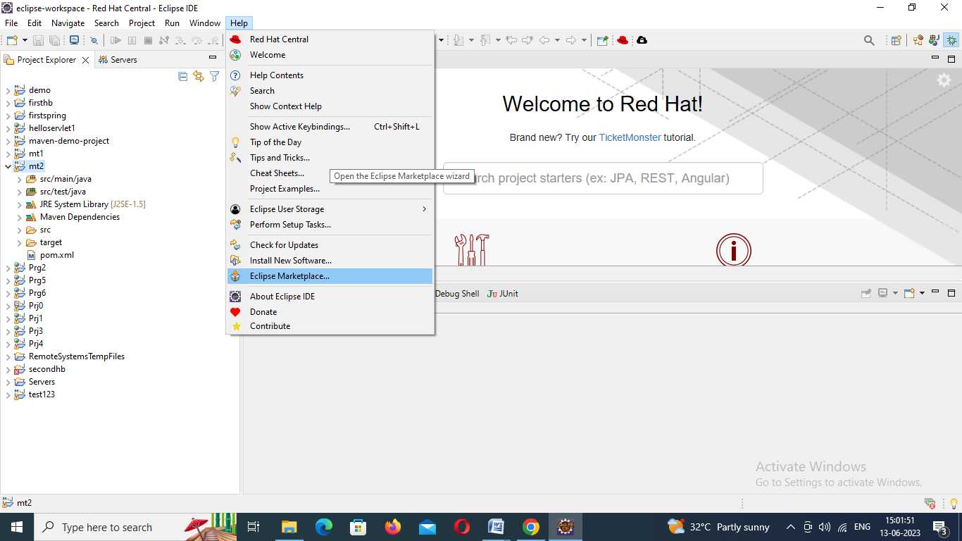
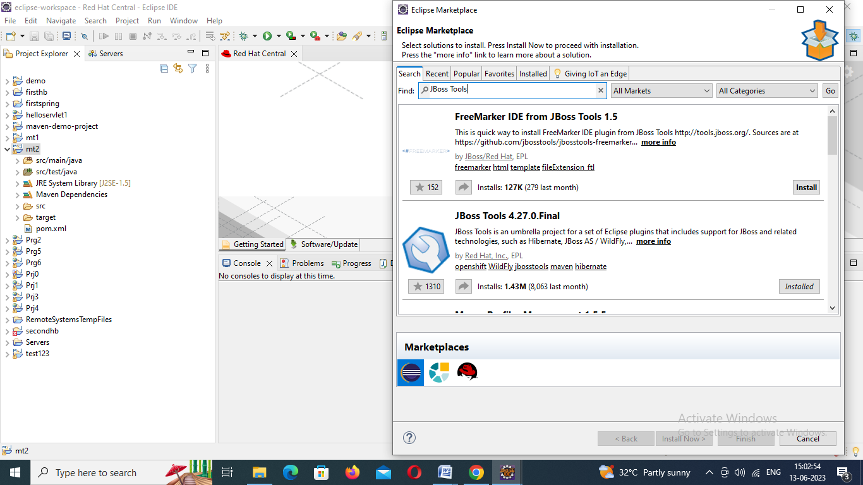

Step 3: Add the dependency to the pom.xml file
Include following dependencies available in mvnrepository.com in pom.xml file
- Hibernate core 4.1.6
- Mysqlconnector 8.0.32
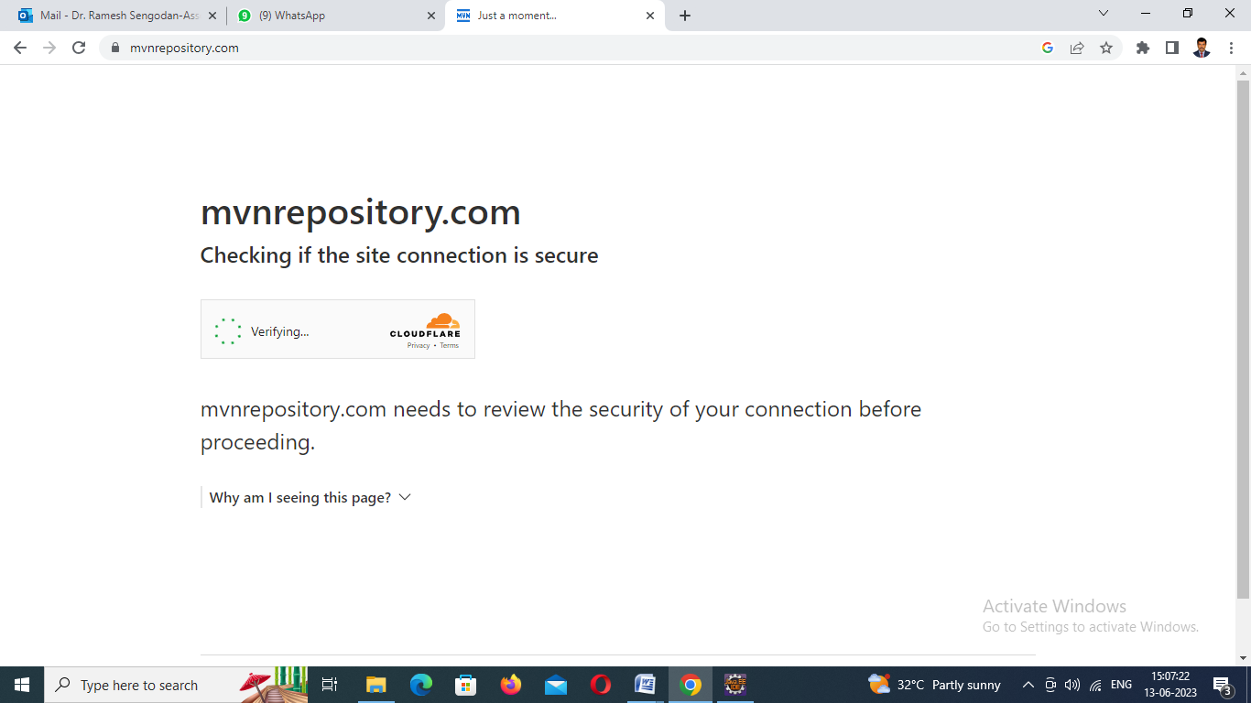
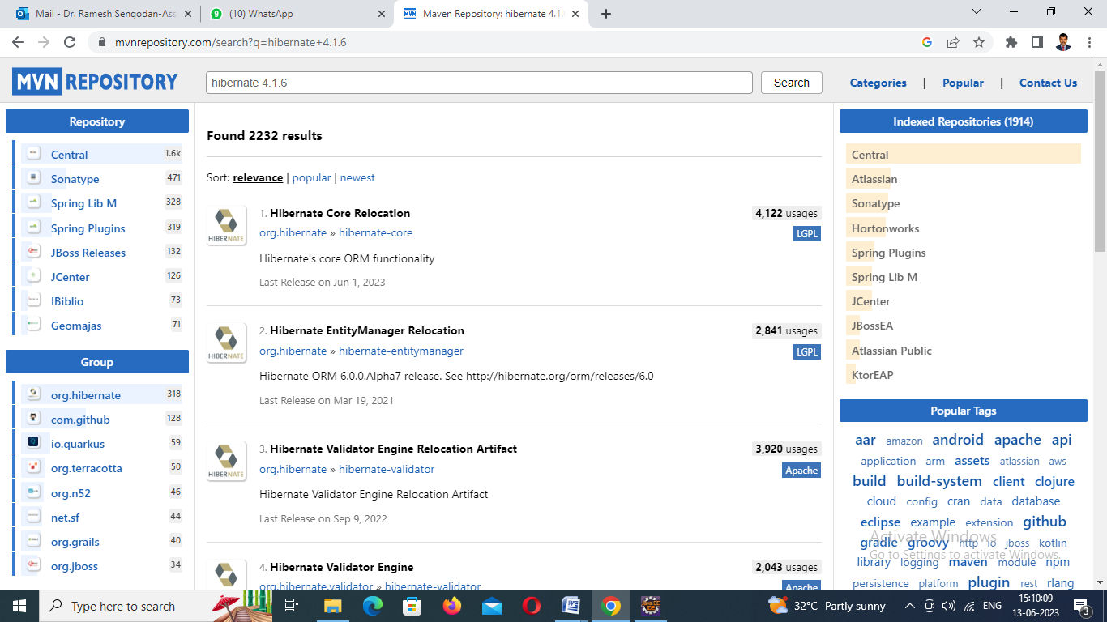
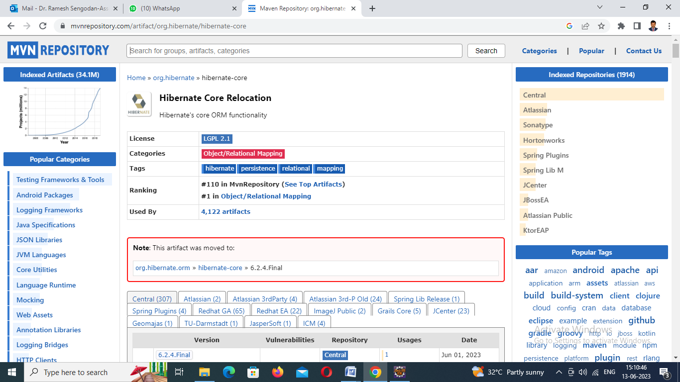

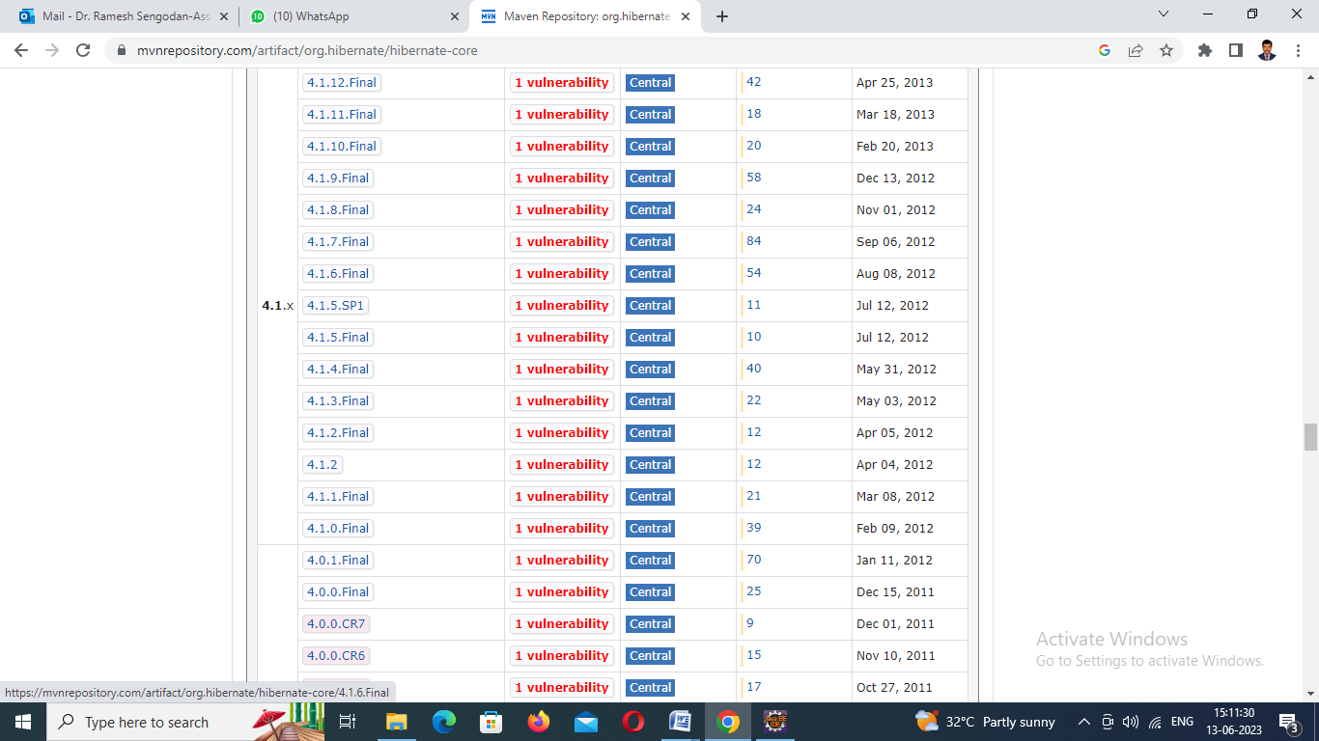

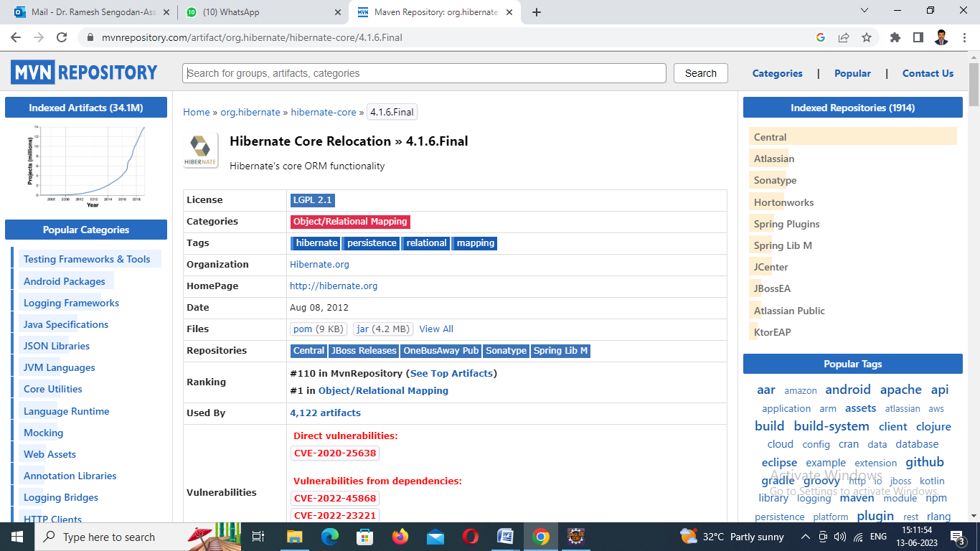
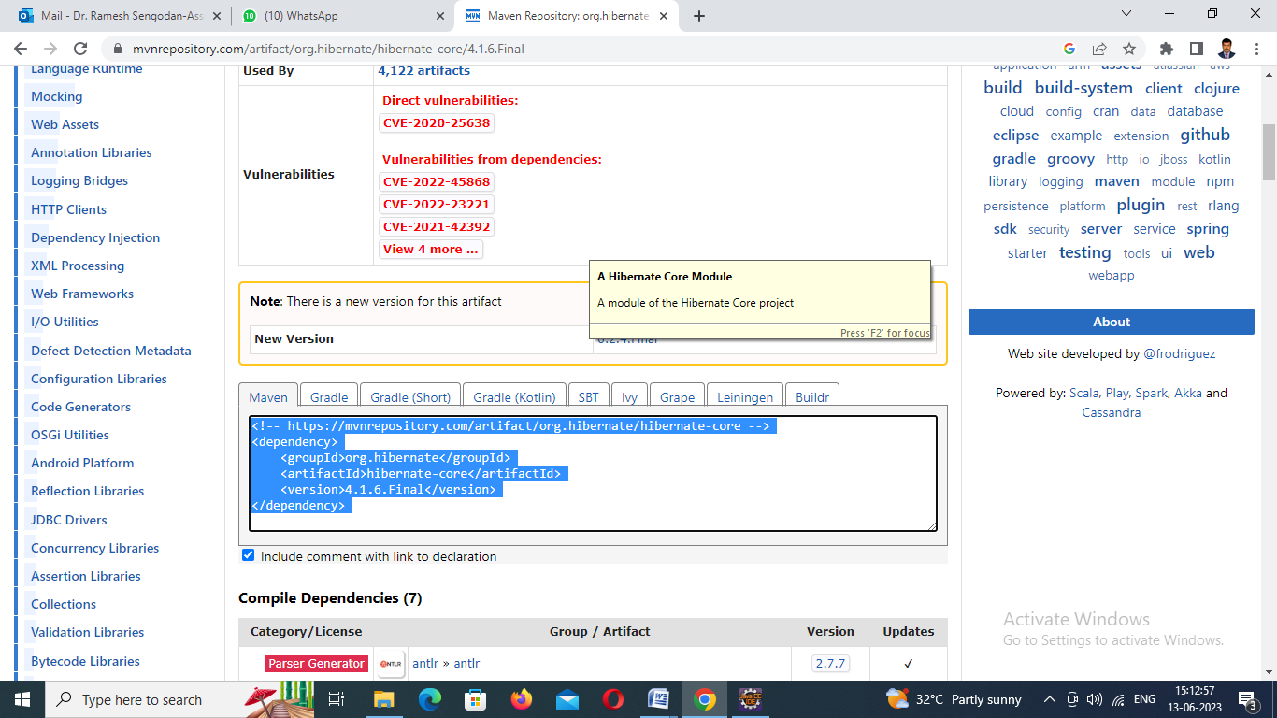

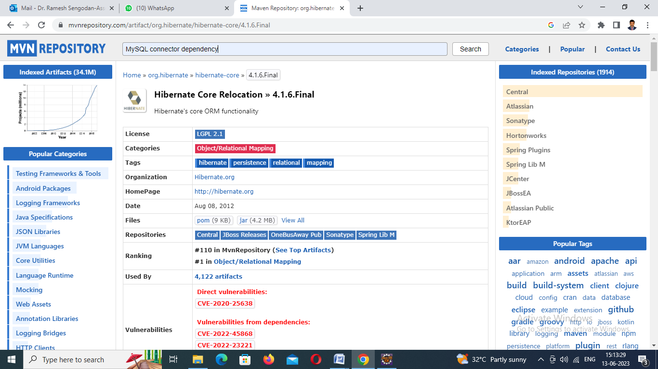
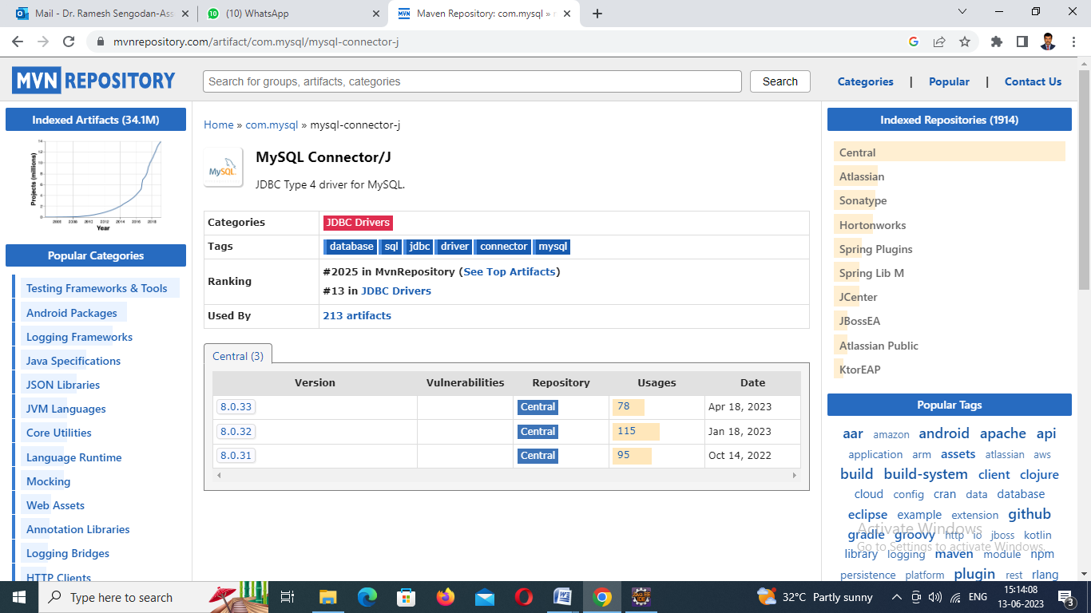

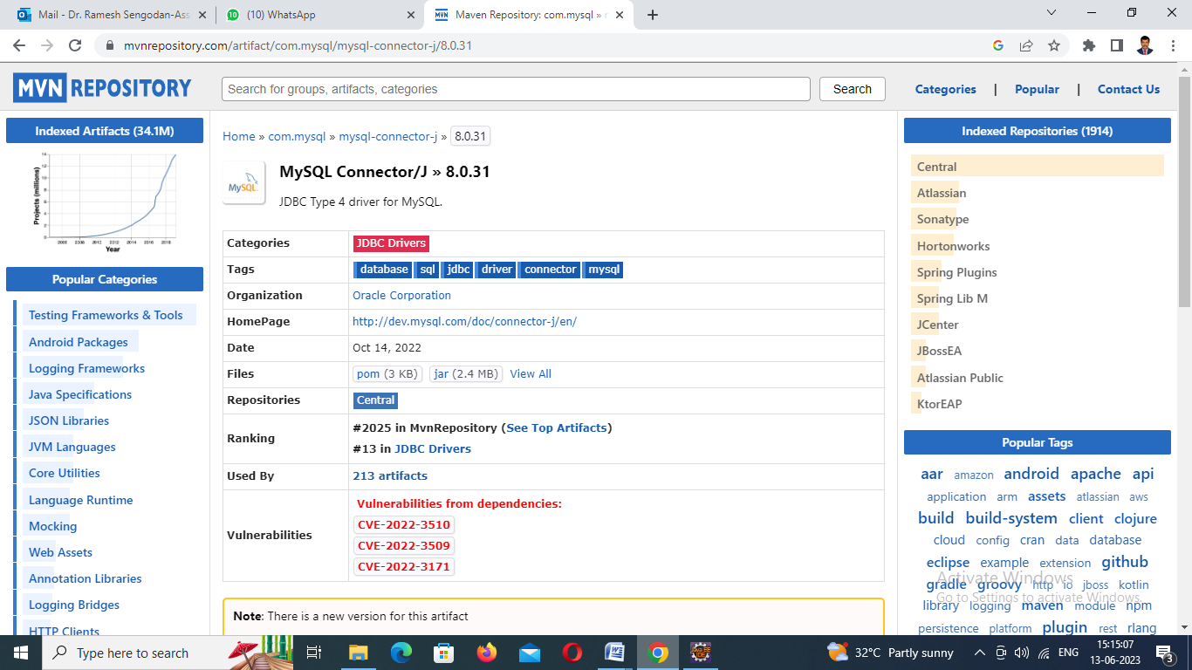
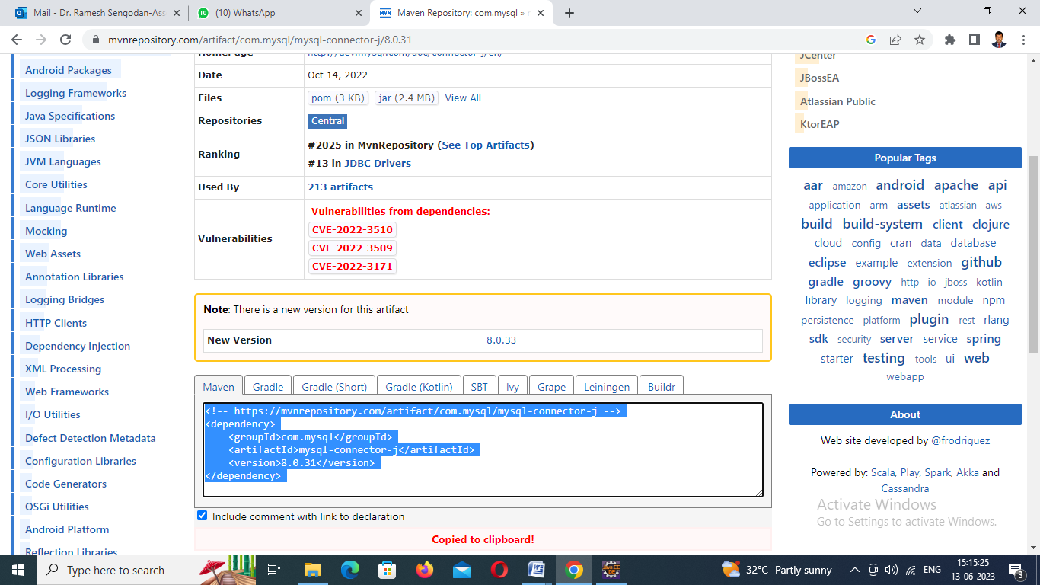

pom.xml file
- XML
<project xmlns="http://maven.apache.org/POM/4.0.0" xmlns:xsi="http://www.w3.org/2001/XMLSchema-instance"
xsi:schemaLocation="http://maven.apache.org/POM/4.0.0 http://maven.apache.org/xsd/maven-4.0.0.xsd">
<modelVersion>4.0.0</modelVersion>

<groupId>com.spring.hibernate</groupId>
<artifactId>Spring-Hibernate</artifactId>
<version>0.0.1-SNAPSHOT</version>
<packaging>jar</packaging>

<name>Spring-Hibernate</name>
<url>http://maven.apache.org</url>

<properties>
<project.build.sourceEncoding>UTF-8</project.build.sourceEncoding>
</properties>

<dependencies>
<dependency>
<groupId>junit</groupId>
<artifactId>junit</artifactId>
<version>3.8.1</version>
<scope>test</scope>
</dependency>

<!-- https://mvnrepository.com/artifact/org.hibernate/hibernate-core -->
<dependency>
<groupId>org.hibernate</groupId>
<artifactId>hibernate-core</artifactId>
<version>5.6.14.Final</version>
</dependency>

<!-- https://mvnrepository.com/artifact/com.mysql/mysql-connector-j -->
<dependency>
<groupId>com.mysql</groupId>
<artifactId>mysql-connector-j</artifactId>
<version>8.0.31</version>
</dependency>
</dependencies>
</project>

Step 4: Add POJO and main classes for working with the functionalityTo create a POJO(Module) class file.

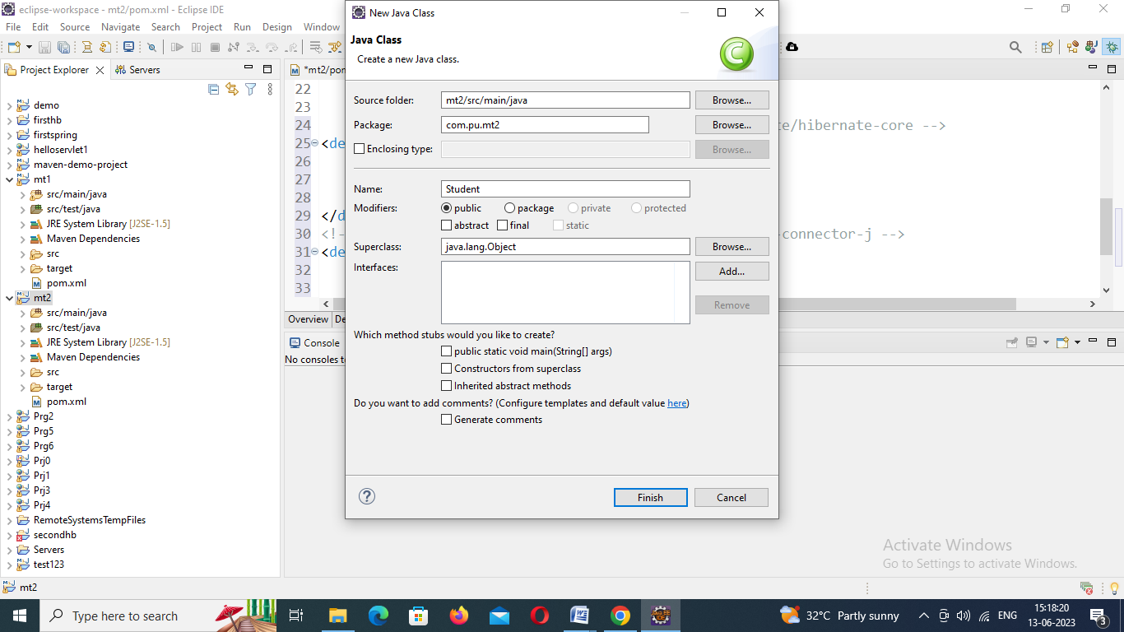
Student.java
package com.pu.test123;

import javax.persistence.Entity;
import javax.persistence.Id;

@Entity
public class Student {
@Id
private int roll;
private String name;
private int marks;
public int getRoll() {
return roll;
}
public void setRoll(int roll) {
this.roll = roll;
}
public String getName() {
return name;
}
public void setName(String name) {
this.name = name;
}
public int getMarks() {
return marks;
}
public void setMarks(int marks) {
this.marks = marks;
}

}

Step 5: Step 3: Add hibernate.cfg.xml file for database parametersTo create hibernate configuration file
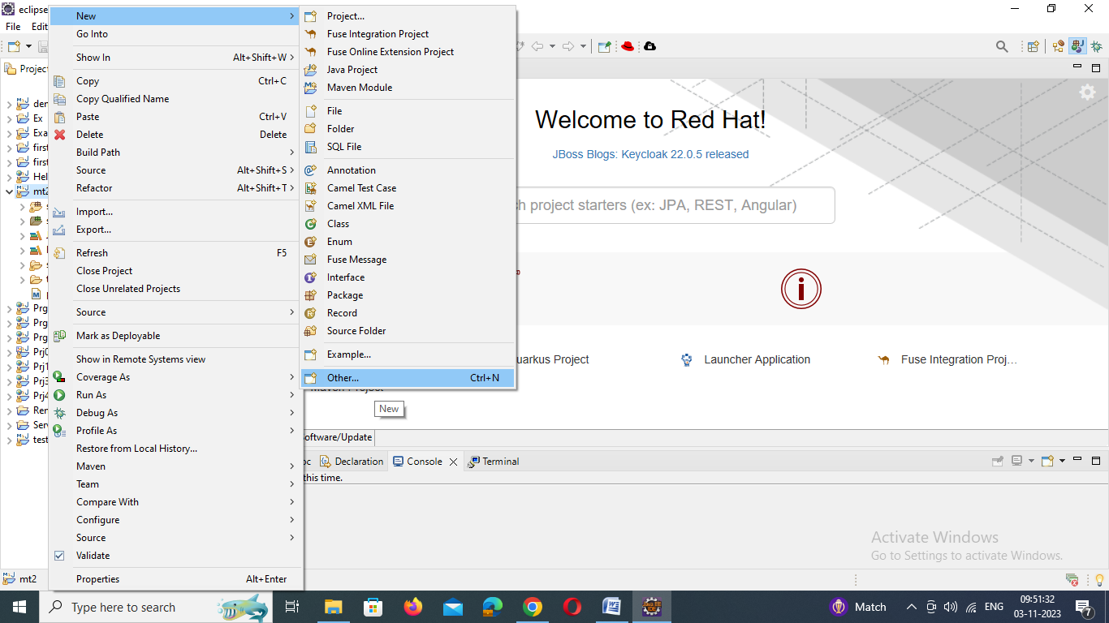

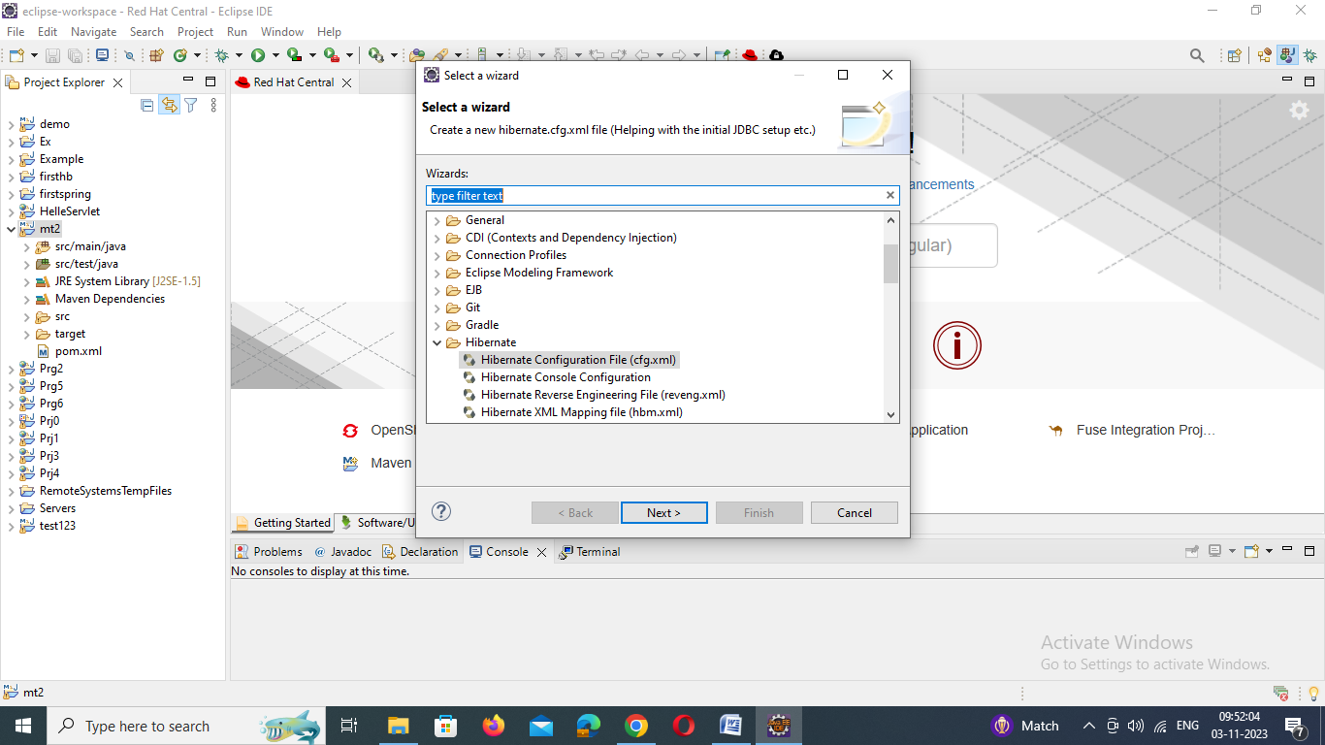

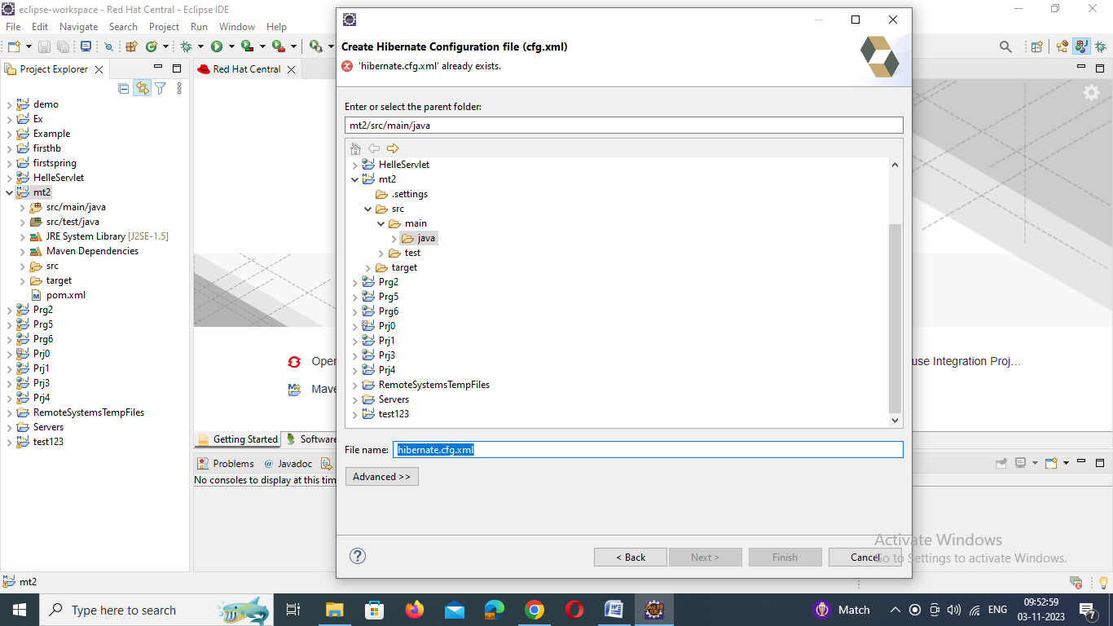

4. MySQL Database Setup
Let's create a database named "demo" in MySQL:
CREATE DATABASE 'demo';
Note: Hibernate will create Student tables automatically
Create table Student(roll int,name varchar(30),marks int);

Hibernate.cfg.xml
<?xml version="1.0" encoding="utf-8"?>
<!DOCTYPE hibernate-configuration PUBLIC
"-//Hibernate/Hibernate Configuration DTD 3.0//EN"
"http://www.hibernate.org/dtd/hibernate-configuration-3.0.dtd">

<hibernate-configuration>
<session-factory>
<property name="hibernate.connection.driver_class">com.mysql.jdbc.Driver</property>
<property name="hibernate.connection.url">jdbc:mysql://localhost:3306/god?characterEncoding=latin1</property>
<property name="hibernate.connection.username">root</property>
<property name="hibernate.connection.password">admin123</property>
<property name="hibernate.dialect">org.hibernate.dialect.MySQLDialect</property>
<property name="show_sql">true</property>
<property name="format_sql">true</property>
<property name="hbm2ddl.auto">update </property>
<mapping resource="com.pu.student.hbm.xml" />
</session-factory>
</hibernate-configuration>

Open App file and edit
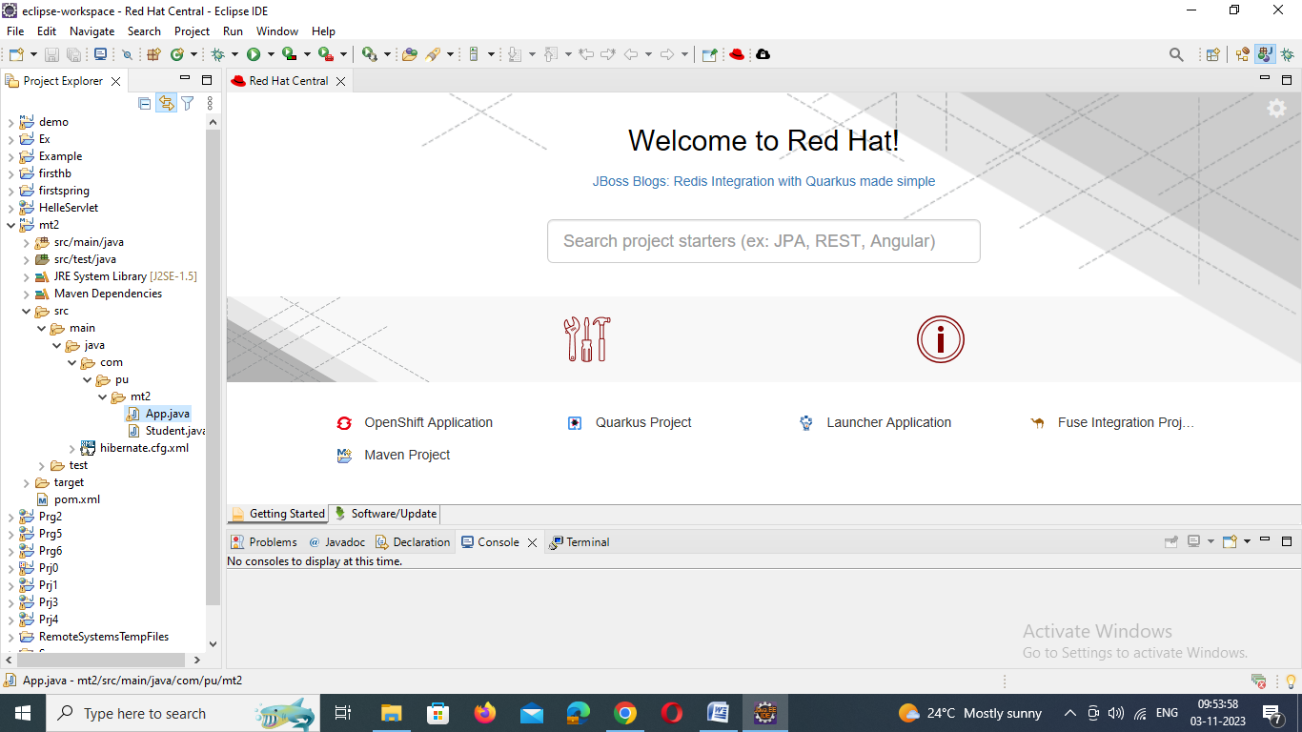
App.java
package com.pu.test123;

import org.hibernate.Session;
import org.hibernate.SessionFactory;
import org.hibernate.Transaction;
import org.hibernate.cfg.Configuration;
/**
* Hello world!
*
*/
public class App
{
public static void main( String[] args )
{
Student student = new Student();
student.setRoll(1);
student.setName("god");
student.setMarks(100);
//1. create Configuration object
Configuration configuration=new Configuration().configure().addAnnotatedClass(Student.class);
//2. create Session Factroy object
SessionFactory sessionFactory=configuration.buildSessionFactory();
//3. Create Session object
Session session=sessionFactory.openSession();
//4. Begin your transaction
Transaction transaction=session.beginTransaction();
//5.Save your object to database
session.save(student);
//6/ Commit your transaction
transaction.commit();
session.close();
sessionFactory.close();
}
}

